**INDEPENDENT READING, SECOND HALF of BOOK** NAME: ____________________________

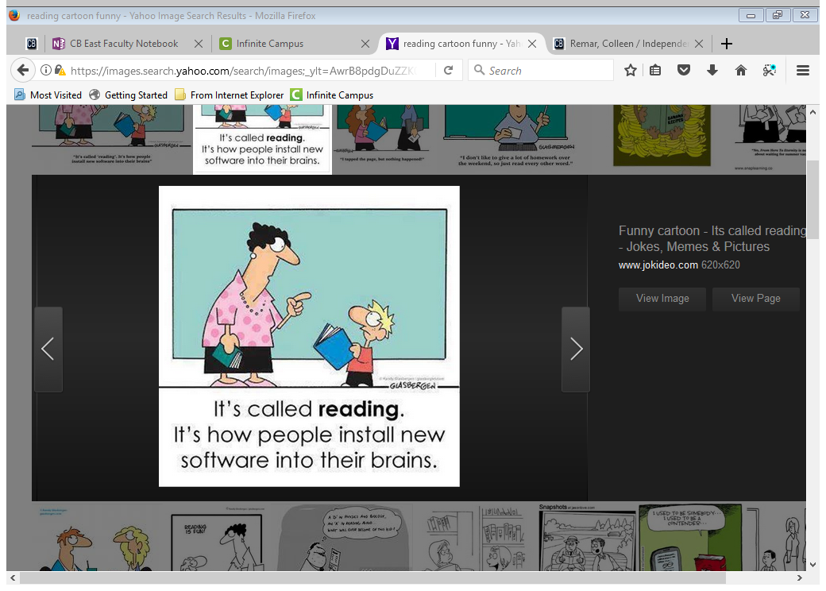

For the second half, you still need to use post its, but you will do so in a more focused manner to prepare for the final project. Follow directions below for the type of book you are reading. Make sure post its are legible, in pen, and hanging out the top or bottom so I can find them. Remember that for a post it on identity, consider:

* How does the book define identity?
* How do characters see themselves (in terms of community, religion, ethnicity, culture, school, family, job, extra-curriculars, race, class, gender, sexual orientation)
* How do others see characters (in terms of the same issues above)

**FICTION** **POST ITS (8 total)**

* 2 on setting
* 2 on conflict
* 1 on a style/story-telling technique
* 3 on identity

**NONFICTION** **POST ITS (8 total)**

* 2 on setting
* 2 on conflict
* 1 on an element of SOAPSTone
* 3 on identity

**GRAPHIC NOVEL** **POST ITS (8 total)**

* 2 on setting
* 2 on conflict
* 1 on a characteristic of the graphic novel
* 3 on identity

**INDEPENDENT READING, SECOND HALF of BOOK** NAME: ____________________________



For the second half, you still need to use post its, but you will do so in a more focused manner to prepare for the final project. Follow directions below for the type of book you are reading. Make sure post its are legible, in pen, and hanging out the top or bottom so I can find them. Remember that for a post it on identity, consider:

* How does the book define identity?
* How do characters see themselves (in terms of community, religion, ethnicity, culture, school, family, job, extra-curriculars, race, class, gender, sexual orientation)
* How do others see characters (in terms of the same issues above)

**FICTION** **POST ITS (8 total)**

* 2 on setting
* 2 on conflict
* 1 on a style/story-telling technique
* 3 on identity

**NONFICTION** **POST ITS (8 total)**

* 2 on setting
* 2 on conflict
* 1 on an element of SOAPSTone
* 3 on identity

**GRAPHIC NOVEL** **POST ITS (8 total)**

* 2 on setting
* 2 on conflict
* 1 on a characteristic of the graphic novel
* 3 on identity